**Teach Yourself**

**Documentation**

Content

1. Introduction

1. Task force

2. Project Aim and Purposes

1. Project Description

1. Technologies

2. System Requirements Specification

1. Planning
2. Architecture
3. Management
4. Realization
5. Frontend
6. Backend
7. Technical Challenges/Issues
8. Milestones
9. Contact and Helpdesk
10. Summary

I. Introduction

Nowadays the world is ruled by technology, because everyone is using it. We are under its power. We are doing our shopping most of the time online, we learn online, we chat with our family, and friends online. As TechYourself team, we wanted to create an application that helps students in organized learning. The TeachYourself application is a platform that gives the opportunity to the user to organize their information. If you try our product, you have the advantage of store your questions/problems and their answers as well.

1. Our Goal

Our project’s goal is make learning more easier by creating a smarter text editor that would help students learn by noticing questions, and then to find a perfectly suitable answer to it. You can group your questions by thematic. This means that if you create a class with sport thematic, in this class will be questions about sport(athlets,championships, evolution of sports). This method will help the user to make a well organised notes, sorted by thematic, or to find what they are searching for between them.

2. Task Force

A munkacsapatot Fabian Ervin es Szabo Huba alkotjak, Szanto Zoltan felugyelete alatt.

II. Project Description

At the planning of the project one of the most important point of view was to implement the whole project in Python programming language for developing and deepening our knowledge in that aspect.

1. Technologies

The project has been done on Windows 10 operating system using Python programming language in PyCharm environment. The Graphical User Interface was made with Kivy technology -a Python plugin. For database we used SQLite3.

1. Requirements
   1. User Requirements

!!IDE JONNEK A USE CASE DIAGRAMOK

* 1. System Requirements

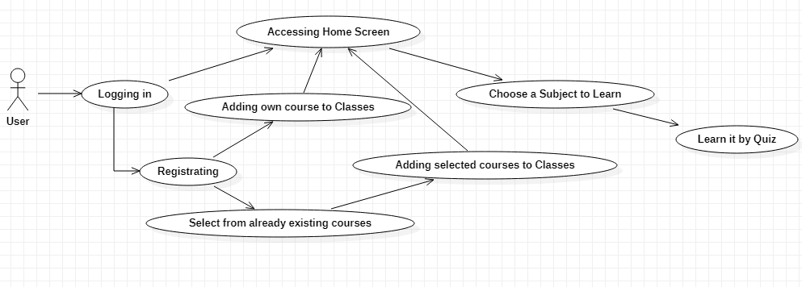

i.Functional Requirements

ii. Non-Functional Requirements

III.Planning

1. Architecture
2. Management

IV.Realization

1. Frontend
2. Backend
3. Technical Challenges/Issues

V.Summary

We are sure aware of the fact that the implemented functionalities are very primitive.